<!--This file created 2:29 PM 10/29/97 by Claris Home Page version 2.0-->14.6 Project
Archimedes' Floating Paraboloid

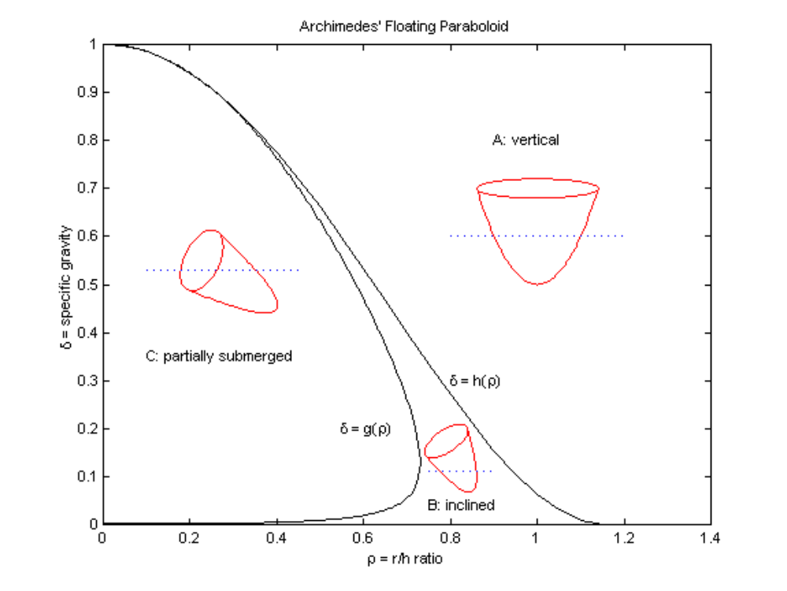
The greatest tour de force in ancient Greek mathematics was Archimedes' investigation of the floating positions of a "right segment" of a circular paraboloid — like the solid bounded below by the paraboloid z = k(x² + y²) and above by the horizontal plane z = h, which has height h and (upper) circular base radius 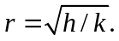 His results are summarized by the following figure, which illustrates three possible floating positions of the solid paraboloid relative to the (blue dashed) water line
The way in which the paraboloid floats is determined by two parameters — its shape ratio ρ = r / h and its specific gravity δ (the ratio of its uniform density to that of water). The curves

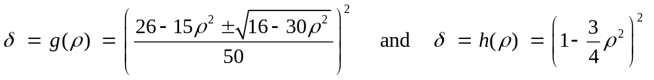

divide the first quadrant of the ρδ-plane into three regions A, B, and C as shown in the figure. Given a right circular paraboloid segment with shape ratio ρ and specific gravity δ (between 0 and 1), Archimedes showed that it floats

- in a vertical upright position if the point (ρ, δ) lies in region A,
- in an inclined position with its base above water if the point (ρ, δ) lies in
region B,
- with its base partially submerged if the point (ρ, δ) lies in region C.

Here are some preliminary exercises to check your understanding of the "classifying figure" above.

Exercise 1 If 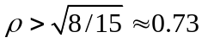 then the paraboloid floats with its base entirely above water.

Exercise 2 If 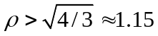 then the paraboloid floats in a vertical position.

Exercise 3 If the paraboloid is made of cork with density δ = 0.25, then it floats with its base partially submerged if 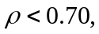 in an inclined position with its base above water if 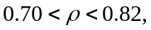 and in a vertical position if 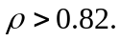

Exercise 4 If the paraboloid has shape ratio ρ = 0.8, then it floats in an inclined position with its base above water if 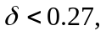 but in a vertical position if 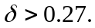

Exercise 5 If the paraboloid has shape ratio ρ = 0.7, then it floats in an inclined position with its base above water if 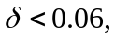 with its base partially submerged if 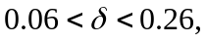 and in a vertical position if 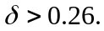

The Inclined Position

This is the most interesting case. The portion of the solid circular paraboloid that lies beneath the water line has the shape of an "oblique segment" of a paraboloid — one that is cut off from the original (vertical) paraboloid by a non-horizontal plane. The depth to which the floating paraboloid sinks in the water, as well as its angle of inclination from the vertical, are determined by Archimedes' law of buoyancy, which implies that

- the weight of the water displaced by the segment beneath the water line equals the weight of the whole floating paraboloid, and

- the two centroids — that of the whole floating paraboloid, and that of the segment beneath the water line — lie on the same vertical line (else gravity would cause the floating paraboloid to rotate one way or the other).

An Oblique Segment of a Paraboloid

Consequently, the crux of Archimedes' analysis was his determination of the volume and centroid of an oblique segment of a paraboloid. For your own personal oblique segment to investigate, let T be the solid that is bounded below by the circular paraboloid
z = x² + y² and below by the plane

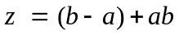

where a denotes the smallest nonzero digit and b the largest digit in your student I.D. number. Your task is to find the volume and the centroid of T. Here's a picture of such an oblique segment:
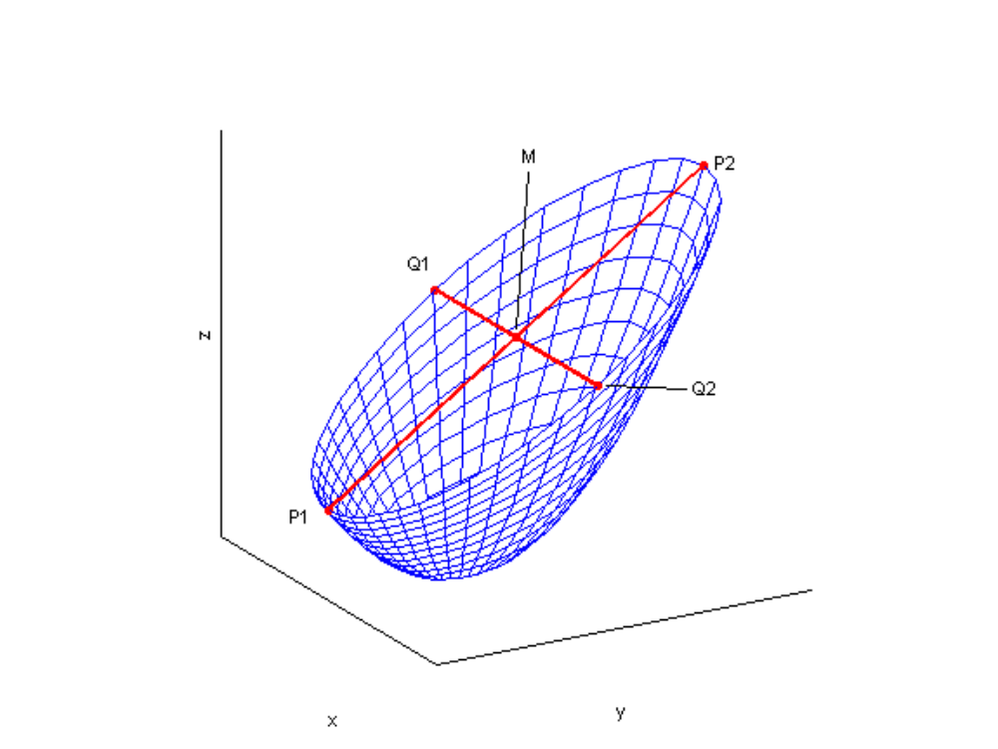
The segment T is symmetric about the vertical yz-plane. In the case a = 1, b = 2 its volume is given by the multiple integral

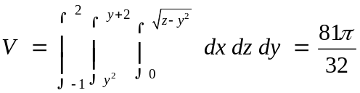

of Example 5 in the text. By symmetry, the x-coordinate of its centroid C is x_{C} = 0. The y- and z-coordinates of C (still with a = 1, b = 2) are given by the multiple integrals

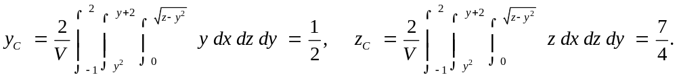

Of course, you will need to insert the z- and y-limits corresponding to your own values of a and b. We recommend that — as an experience worth the effort — you evaluate your three multiple integrals manually, taking the solution of Example 5 in the text as a model. That is,

- First integrate (trivially) with respect to x.
- Then integrate (easily) with respect to z, leaving you with an integral involving the ³/₂-power of a quadratic in y.
- Complete the square to express this quadratic in the form 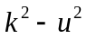 where
- Make the trigonometric substitution 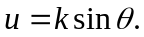
- Finally, use (as necessary) the tabulated integral of 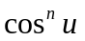 inside the back cover of the textbook.

In the technology-specific sections of this project we illustrate the automated computer algebra calculation of the volume and centroid of T.

Archimedes' Answers

As indicated in the 3-dimensional figure on the preceding page, the (top) base of our oblique segment is an ellipse with major axis P₁P₂, minor axis Q₁Q₂, and center M. The 2-dimensional figure at the top of the next page shows the intersection of the segment with the vertical yz-plane.

The vertex V of the oblique segment is the point of the paraboloid at which its tangent plane is parallel to its base. Archimedes showed that

- The volume of the segment is 3/2 that of the inscribed ellipsoidal cone with the same vertex and base.
- The centroid of the segment lies on its axis VM and is 2/3 of the way from V to M.

For a worthy challenge, verify that your own volume and centroid results agree with these results of Archimedes. A worthy challenge for both you and your computer algebra system is to show that the region bounded below by the paraboloid 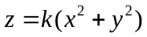 and above by the plane 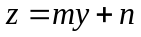 has volume

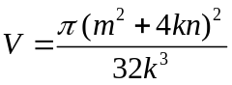

and centroid 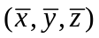 with coordinates

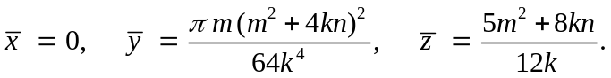

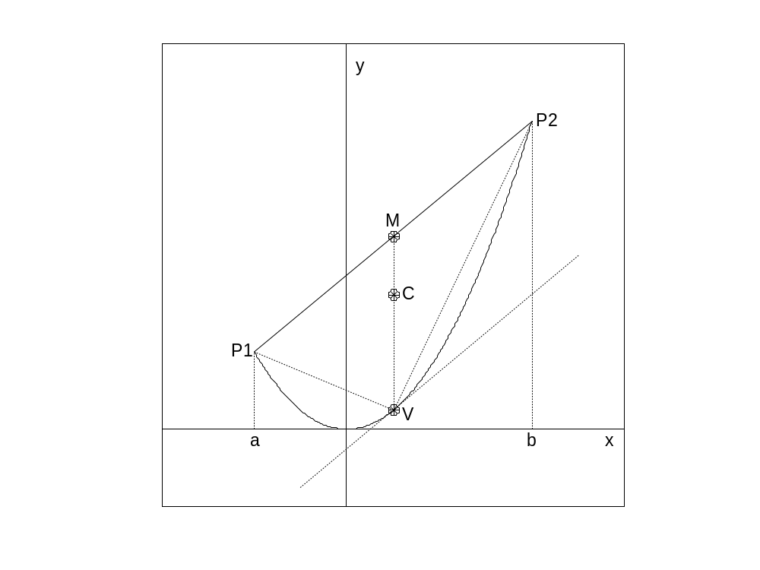

Using Maple

Taking a = 1 and b = 2 for an example, we want to investigate the segment of a
paraboloid that is bounded below by the paraboloid z = x² + y² and above by the plane
z = y + 2.

If we view this oblique segment looking inward along the x-axis, we see that it is bounded front-and-back by the surfaces

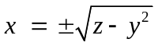

defined on the yz-region that is bounded above by the line z = y + 2 and below by the parabola z = y². This region lies over the interval –1 < y < 2 on the y-axis.

plot({y+2, y^2}, y=-1..2, color=blue, thickness=2);
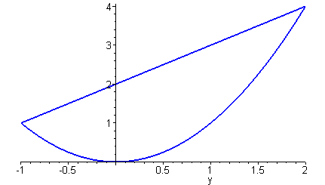

Consequently, we can calculate the segment's volume by evaluating the triple integral

V := int(
int(
int(1, x=-sqrt(z-y^2)..sqrt(z-y^2)),
z=y^2..y+2),
y=-1..2);

V := 81 π/32

Because of the segment's symmetry about the vertical y-plane, the x-coordinate of its centroid is x_{C} = 0. We need only divide by V and replace the integrand 1 by y or z to calculate the y- or z- coordinate of the centroid.
The y-coordinate of its centroid is

yC := (1/V)*int(
int(
int(y, x=-sqrt(z-y^2)..sqrt(z-y^2)),
z=y^2..y+2),
y=-1..2);

yC := 1/2

The z-coordinate of its centroid is

zC := (1/V)*int(
int(
int(z, x=-sqrt(z-y^2)..sqrt(z-y^2)),
z=y^2..y+2),
y=-1..2);

zC := 7/4

Thus our oblique segment of a paraboloid has volume 81π/32 and centroid (0, ¹/₂, ⁷/₄).

Archimedes' Way

First we examine he elliptical top base of the segment. Looking at the figure above, we see that the endpoints of the ellipse's major axis are

P1 := [0,-1,1]:
P2 := [0,2,4]:

Hence the center point of the ellipse is

M := (P1 + P2)/2:

Its major semiaxis

MP2 := P2 - M:

has length

with(linalg):
R := sqrt( dotprod(MP2,MP2) ):

The endpoints Q₁ and Q₂ of the minor axis have the same y- and z-coordinates

yq := M[2]:
zq := M[3]:

as M, and x-coordinates determined by

xq := sqrt(zq - yq^2):

Hence

Q1 := [-xq,yq,zq]:
Q2 := [xq,yq,zq]:

so the ellipse has minor semiaxis

MQ2 := Q2 - M:

with length

r := sqrt( dotprod(MQ2,MQ2) ):

Therefore, the area of the elliptical top base of the segment is

A := Pi*r*R;
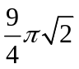

The Volume and Centroid of the Segment

The vertex V of the segment is the point of the parabola z = y² in the yz-plane x = 0 where the tangent line is parallel to the major axis P₁P₂ of the top base. The slope of this line is

m := (P2[3]-P1[3])/(P2[2]-P1[2]):

so the y-coordinate of V is given by

yv := solve(2*y = m, y):

Hence the vertex is

V := [0, yv, yv^2 ]:

The normal vector to the base plane z = y + 2 is

n := [0,-1,1]:

and the height h of the inscribed cone is the component of

VM := M - V:

in the direction of n. The familiar dot product formula therefore gives

h := dotprod(n,VM)/sqrt(dotprod(n,n));

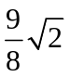

Finally, Archimedes' theorem that the volume of the segment is 3/2 times the volume of the inscribed elliptical cone with the same vertex V gives

volume = (3/2)*(1/3)*A*h;

volume = 81 π / 32

This is the same volume we found by multiple integration. And Archimedes' centroid computation also agrees with our multiple integral computations, because the point on VM that is 2/3 of the way from V to M is

centroid = (2/3)*M + (1/3)*V;
centroid = [0, 1/2, 7/4]

Using Mathematica

Taking a = 1 and b = 2 for an example, we want to investigate the segment of a paraboloid that is bounded below by the paraboloid z = x² + y² and above by the plane
z = y + 2.

If we view this oblique segment looking inward along the x-axis, we see that it is bounded front-and-back by the surfaces

defined on the yz-region that is bounded above by the line z = y + 2 and below by the parabola z = y². This region lies over the interval –1 < y < 2 on the y-axis.

Plot[{y+2, y^2}, {y, -1, 2}];

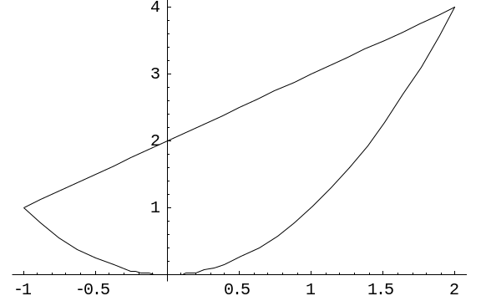

Consequently, we can calculate the segment's volume by evaluating the triple integral

V = Integrate[
Integrate[
Integrate[ 1, {x, -Sqrt[z-y^2], Sqrt[z-y^2]}],
{z, y^2, y + 2}],
{y, -1, 2}]
81 Pi/32

Because of the segment's symmetry about the vertical y-plane, the x-coordinate of its centroid is x_{C} = 0. We need only divide by V and replace the integrand 1 by y or z to calculate the y- or z- coordinate of the centroid.
The y-coordinate of its centroid is

yC = (1/V) Integrate[
Integrate[
Integrate[ y,
{x, -Sqrt[z-y^2], Sqrt[z-y^2]}],
{z, y^2, y + 2}],
{y, -1, 2}]
1/2
The z-coordinate of its centroid is

zC = (1/V) Integrate[
Integrate[
Integrate[ z,
{x, -Sqrt[z-y^2], Sqrt[z-y^2]}],
{z, y^2, y + 2}],
{y, -1, 2}]
7/4

Thus our oblique segment of a paraboloid has volume 81π/32 and centroid (0, ¹/₂, ⁷/₄).

Archimedes' Way

First we examine he elliptical top base of the segment. Looking at the figure above, we see that the endpoints of the ellipse's major axis are

P1 = {0, -1, 1};
P2 = {0, 2, 4};

Hence the center point of the ellipse is

M = (P1 + P2)/2;

Its major semiaxis

MP2 = P2 - M;

has length

R = Sqrt[MP2 . MP2];

The endpoints Q₁ and Q₂ of the minor axis have the same y- and z-coordinates

yq = M[[2]];
zq = M[[3]];

as M, and x-coordinates determined by

xq = Sqrt[zq - yq^2];
Hence
Q1 = {-xq, yq, zq};
Q2 = {xq, yq, zq};

so the ellipse has minor semiaxis

MQ2 = Q2 - M;

with length

r = Sqrt[MQ2 . MQ2];

Therefore, the area of the elliptical top base of the segment is
A = Pi*r*R

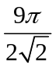

The Volume and Centroid of the Segment

The vertex V of the segment is the point of the parabola z = y² in the yz-plane x = 0 where the tangent line is parallel to the major axis P₁P₂ of the top base. The slope of this line is

m = (P2[[3]]-P1[[3]]) / (P2[[2]]-P1[[2]]);

so the y-coordinate of V is given by

yv = First[y /. Solve[2*y == m, y]];

Hence the vertex is

V = {0, yv, yv^2};

The normal vector vector to the base plane z = y + 2 is

n = {0, -1, 1};

and the height h of the inscribed cone is the component of

VM = M - V;

in the direction of n. The familiar dot product formula therefore gives

h = n . VM/Sqrt[n . n]
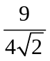

Finally, Archimedes' theorem that the volume of the segment is 3/2 times the volume of the inscribed elliptical cone with the same vertex V gives

volume = (3/2)*(1/3)*A*h
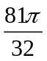81 Pi / 32

This is the same volume we found by multiple integration. And Archimedes' centroid computation also agrees with our multiple integral computations, because the point on VM that is 2/3 of the way from V to M is

centroid = (2/3)M + (1/3)V
{0, 1/2, 7/4}

Using MATLAB

Taking a = 1 and b = 2 for an example, we want to investigate the segment of a paraboloid that is bounded below by the paraboloid z = x² + y² and above by the plane
z = y + 2.

If we view this oblique segment looking inward along the x-axis, we see that it is bounded front-and-back by the surfaces

defined on the yz-region that is bounded above by the line z = y + 2 and below by the parabola z = y². This region lies over the interval –1 < y < 2 on the y-axis, as illustrated in the following figure.
Consequently, we can calculate the segment's volume by evaluating the triple integral

syms x y z
V = int(int(int(1, x,-sqrt(z-y^2),...
sqrt(z-y^2)), z, y^2,y+2), y, -1,2)

V = 81/32*pi

(meaning 81π/32). Because of the segment's symmetry about the vertical y-plane, the
x-coordinate of its centroid is x_{C} = 0. We need only divide by V and replace the integrand 1 by y or z to calculate the y- or z- coordinate of the centroid.
yC = (1/V)*int(int(int(y, x,-sqrt(z-y^2),...
sqrt(z-y^2)), z, y^2,y+2), y, -1,2)
yC = 1/2

zC = (1/V)*int(int(int(z, x,-sqrt(z-y^2),...
sqrt(z-y^2)), z, y^2,y+2), y, -1,2)
zC = 7/4

Thus our oblique segment of a paraboloid has volume 81π/32 and centroid (0, ¹/₂, ⁷/₄).

Archimedes' Way

First we examine he elliptical top base of the segment. Looking at the figure above, we see that the endpoints of the ellipse's major axis are

P1 = [0,-1,1];
P2 = [0,2,4];

Hence the center point of the ellipse is

M = (P1 + P2)/2;

Its major semiaxis

MP2 = P2 - M;

has length

R = norm(MP2);

The endpoints Q₁ and Q₂ of the minor axis have the same y- and z-coordinates

yq = M(2);
zq = M(3);

as M, and x-coordinates determined by

xq = sqrt(zq - yq^2);

Hence

Q1 = [-xq,yq,zq];
Q2 = [xq,yq,zq];

so the ellipse has minor semiaxis

MQ2 = Q2 - M;

with length

r = norm(MQ2);

Therefore, the area of the elliptical top base of the segment is

A = pi*r*R
A =
9.9965
The Volume and Centroid of the Segment

The vertex V of the segment is the point of the parabola z = y² in the yz-plane x = 0 where the tangent line is parallel to the major axis P₁P₂ of the top base. The slope

m = (P2(3)-P1(3)) / (P2(2)-P1(2));

of this line must equal dz/dy = 2y, so the y-coordinate of V is given by

yv = m/2;

Hence the vertex is

V = [0, yv, yv^2 ];

The normal vector vector to the base plane z = y + 2 is

n = [0,-1,1];

and the height h of the inscribed cone is the component of

VM = M - V;

in the direction of n. The familiar dot product formula therefore gives

h = sum(n.*VM)/norm(n);

Finally, Archimedes' theorem that the volume of the segment is 3/2 times the volume of the inscribed elliptical cone with the same vertex V gives

volume = (3/2)*(1/3)*A*h
volume =
7.9522
Because

format rational
volume/pi
ans = 81/32

this is the same volume 81π/32 that we found by multiple integration. And Archimedes' centroid computation also agrees with our multiple integral computations, because the point on VM that is 2/3 of the way from V to M is

centroid = (2/3)*M + (1/3)*V
centroid =
0 1/2 7/4

